Азбука безопасности в картинках

11.01.2017

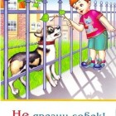

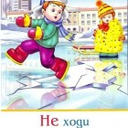  
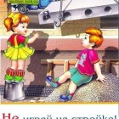

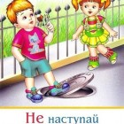

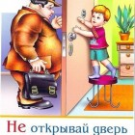

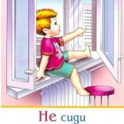

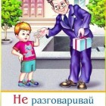

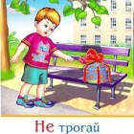

* [](https://134vrzh.tvoysadik.ru/upload/ts134vrzh_new/images/big/b0/c8/b0c88cd7bb4b4461924bd5d91a90d6b2.jpg)
* [](https://134vrzh.tvoysadik.ru/upload/ts134vrzh_new/images/big/46/4b/464be6b93e0062365758688d5b8e97f2.jpg)

* [](https://134vrzh.tvoysadik.ru/upload/ts134vrzh_new/images/big/08/0d/080d8d36100d0bf27b7d0ec9fcb7ae0c.jpg)

* [](https://134vrzh.tvoysadik.ru/upload/ts134vrzh_new/images/big/35/99/359946cd497d046dd3c238d05c69a886.jpg)

* [](https://134vrzh.tvoysadik.ru/upload/ts134vrzh_new/images/big/34/ab/34ab6b2eb50f562d5a1939e949e69232.jpg)
* [](https://134vrzh.tvoysadik.ru/upload/ts134vrzh_new/images/big/a4/6e/a46e9e83ce1670dbc9d70a3b9aaccefc.jpg)

* [](https://134vrzh.tvoysadik.ru/upload/ts134vrzh_new/images/big/eb/e2/ebe23f3b8eeae0ffb29590e7ceba3d3c.jpg)

* [](https://134vrzh.tvoysadik.ru/upload/ts134vrzh_new/images/big/c6/a3/c6a330d45adc0ab4ade295321a02a279.jpg)